EXPT NO: 6 | IMPLEMENTATION OF LSTM FOR SENTIMENT ANALYSIS
DATE: 28-09-2026 | IMPLEMENTATION OF LSTM FOR SENTIMENT ANALYSIS

PRE-LAB QUESTIONS

- What is the purpose of Long Short-Term Memory (LSTM) networks in NLP?
LSTM networks are used to process and understand sequential text data by remembering important information from earlier words in a sequence.

- Why is LSTM preferred over a Simple RNN for processing long text sequences?
LSTM can retain important information for a longer time and reduces the vanishing gradient problem, making it better for long sequences.

- What is sentiment analysis? Give two real-world applications.
Sentiment analysis is the process of identifying the emotional opinion in text, such as positive or negative.
Applications: customer review analysis and social media opinion monitoring.

- Explain the role of tokenization and padding in text preprocessing.
Tokenization converts text into individual words or tokens. Padding makes all sequences the same length so they can be processed by the LSTM.

- What is word embedding? Why is it useful for sentiment analysis?
Word embedding converts words into numerical vectors that capture their relationships and meanings. It helps the model understand words and their sentiment-related patterns.

AIM
To implement a Long Short-Term Memory (LSTM) network for sentiment analysis by performing text preprocessing, tokenization, sequence generation, and embedding using NLP libraries, and classify text into sentiment categories.

SOFTWARE REQUIREMENTS
- Python
- TensorFlow / Keras
- Google Colab
- GitHub
- NumPy
- Pandas
- Matplotlib
- NLP libraries – NLTK / spaCy
- Scikit-learn

OBJECTIVES
Students will be able to:
- Understand the architecture and working of LSTM networks.
- Perform text preprocessing techniques for sentiment analysis.
- Tokenize and convert textual data into numerical sequences.
- Generate word embeddings for textual data.
- Build and train an LSTM model for sentiment classification.
- Evaluate the performance of the trained LSTM model.
- Analyze the effect of preprocessing and embedding on sentiment classification.

PROCEDURE
PART A: DATASET PREPARATION AND TEXT PREPROCESSING
- Perform the following tasks:
- Load a sentiment analysis dataset such as the IMDB Movie Reviews dataset.
- Explore the dataset and examine sample positive and negative reviews.
- Check the number of samples and sentiment class distribution.
- Perform text preprocessing using NLP libraries.
- Convert text to lowercase.
- Remove unnecessary punctuation and special characters.
- Remove stop words, if required.
- Tokenize the reviews into words/tokens.
- Convert the tokens into numerical sequences using a tokenizer.
- Build a vocabulary from the training reviews.
- Apply sequence padding to obtain equal-length input sequences.
- Encode sentiment labels into numerical form.
- Split the prepared dataset into training and testing/validation datasets.

Screenshot of the code and output :

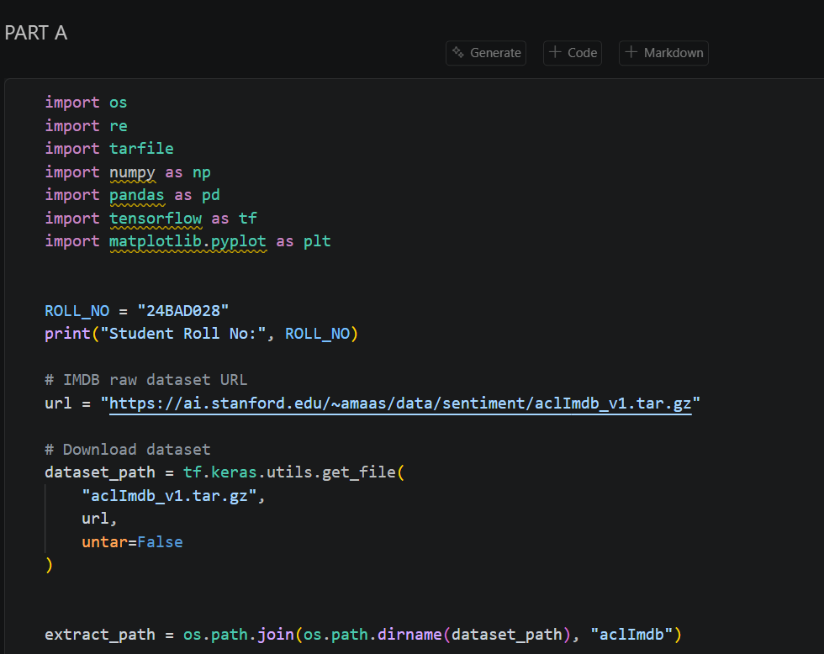
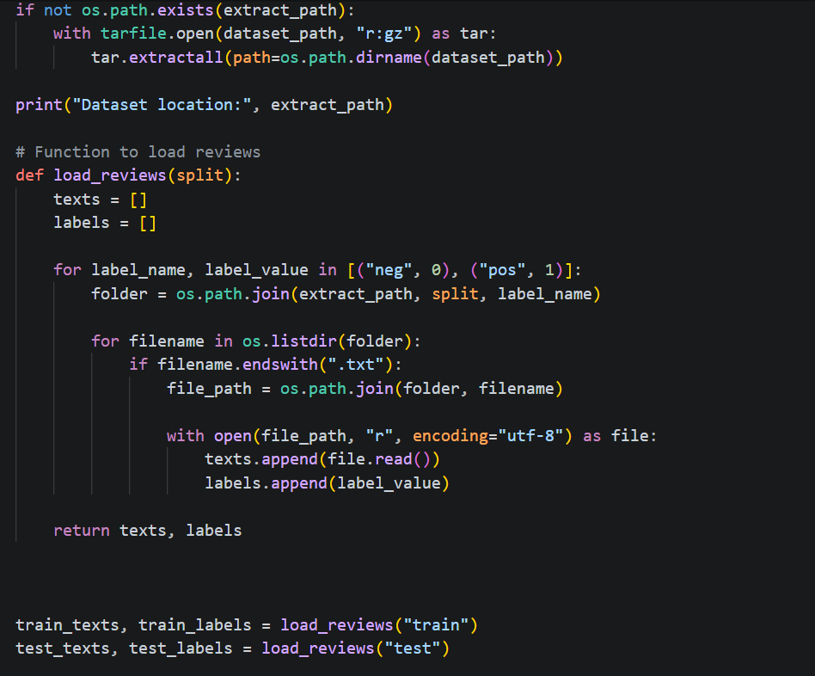
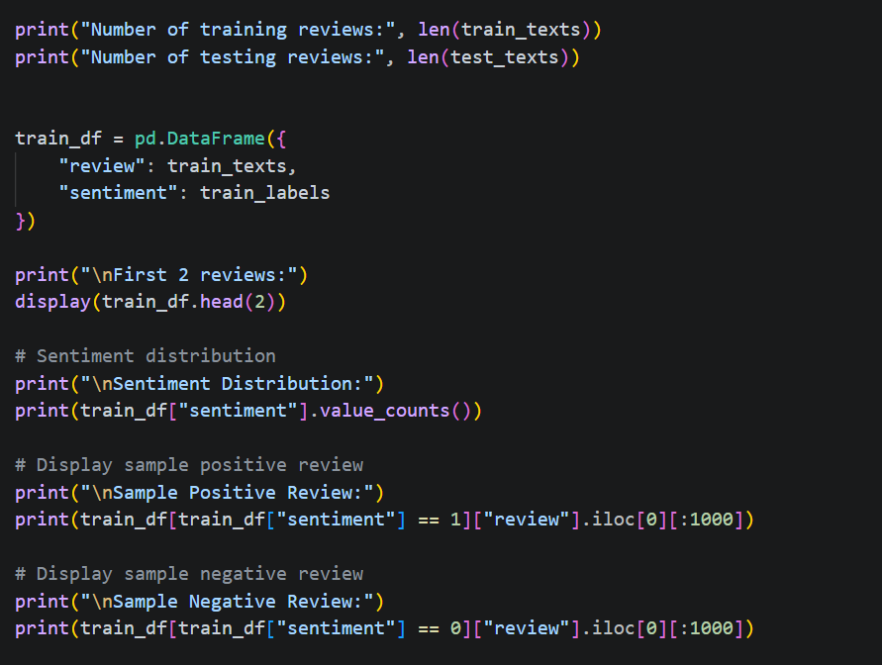
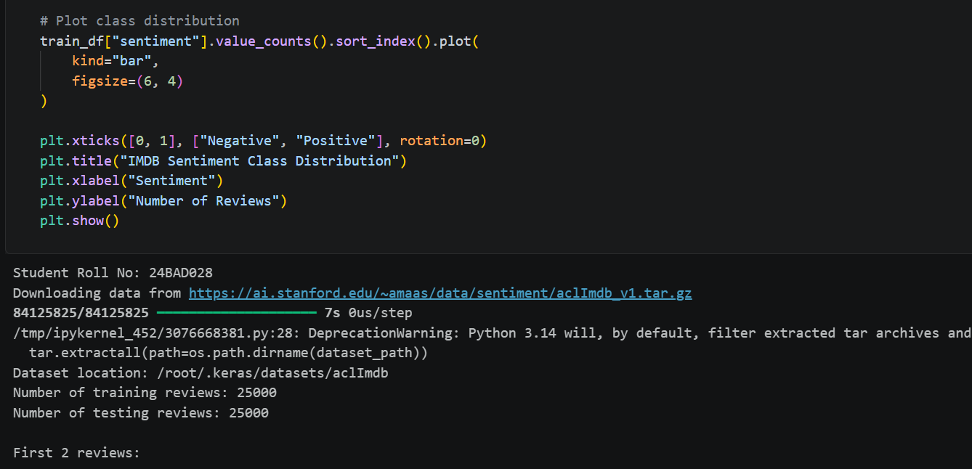
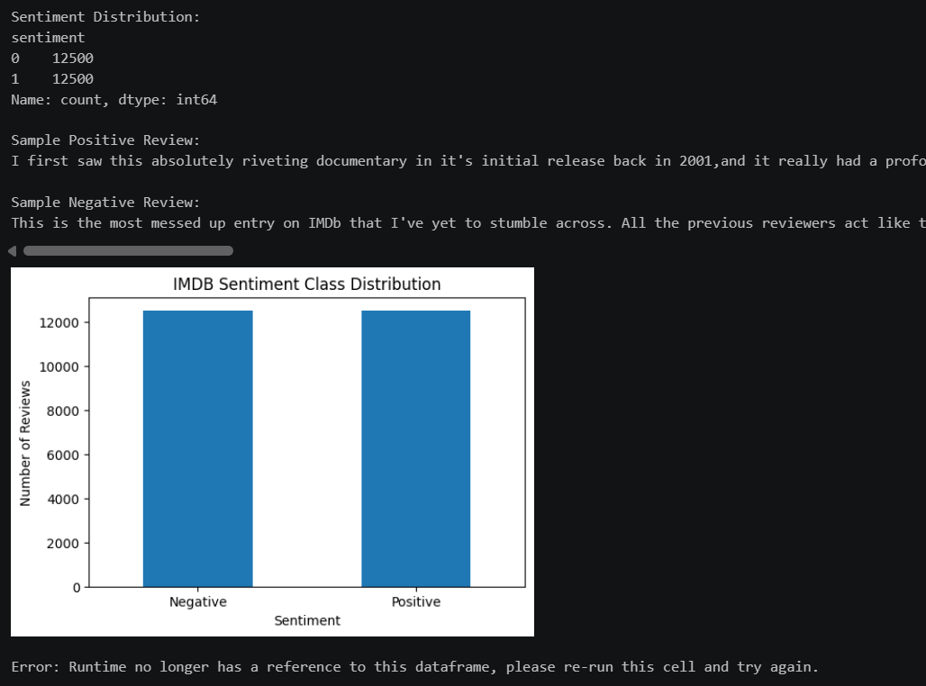

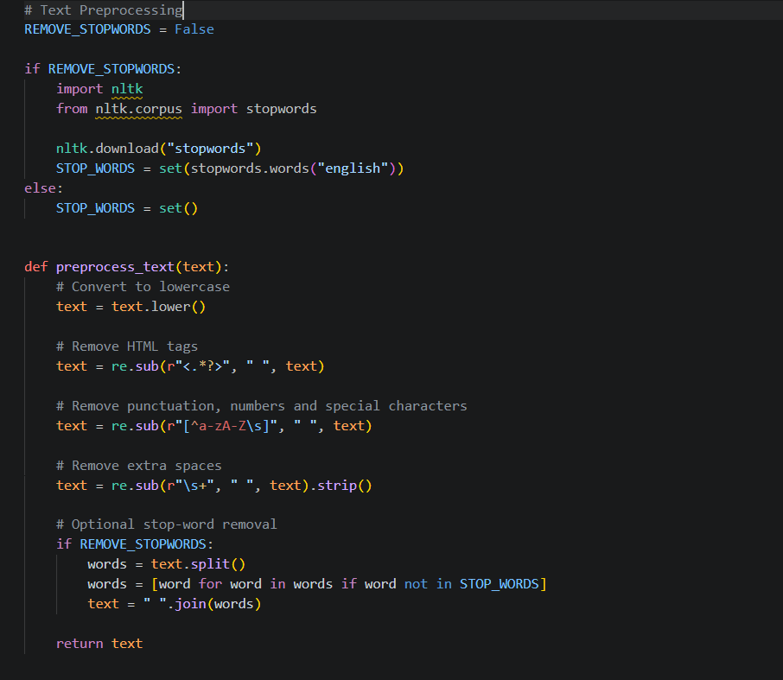
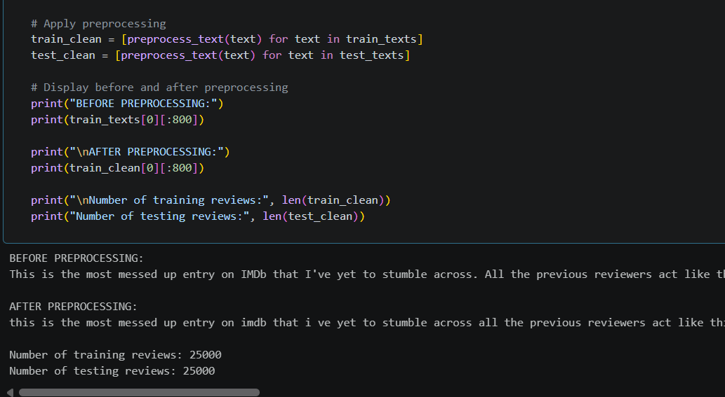
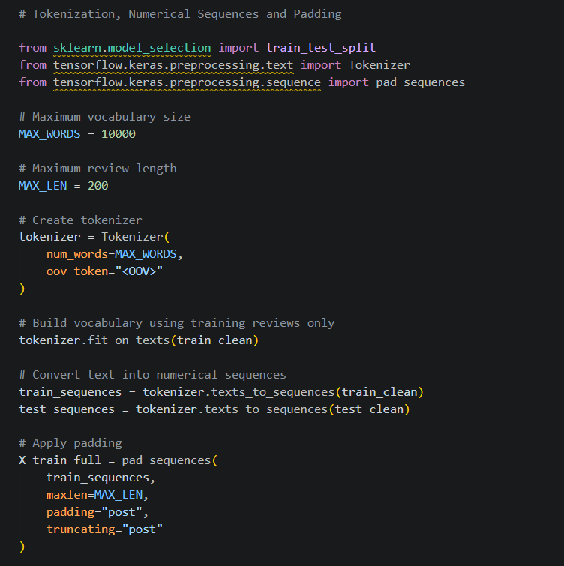
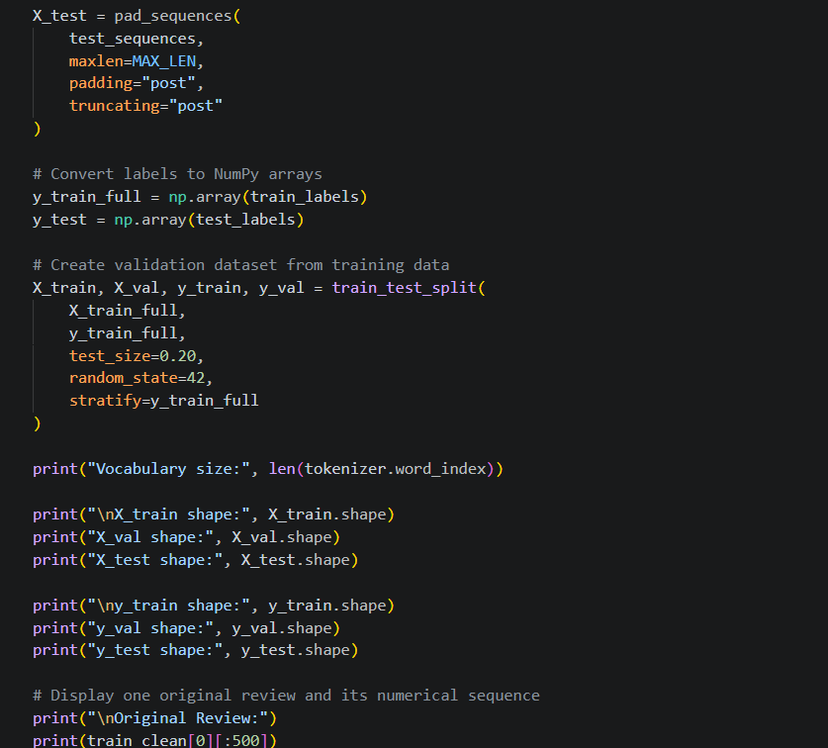
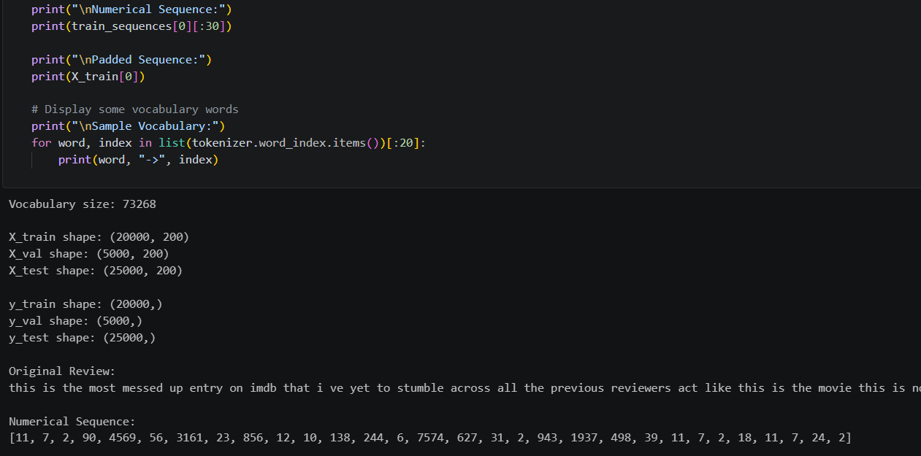
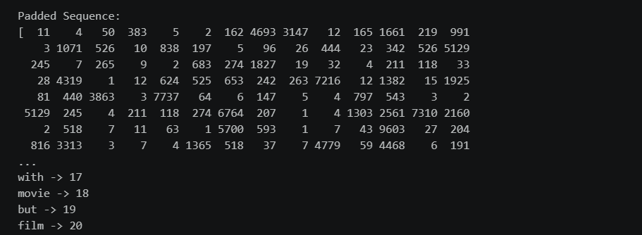

PART B: EMBEDDING GENERATION
Perform the following tasks:
- Generate numerical representations of the pre-processed text.
- Create an Embedding layer using Keras/TensorFlow.
- Define the vocabulary size and embedding dimension.
- Convert tokenized sequences into dense vector representations.
- Display the shape of the generated embedding representation.
- Analyze how words are represented in the embedding space.

Screenshot of the code and output :

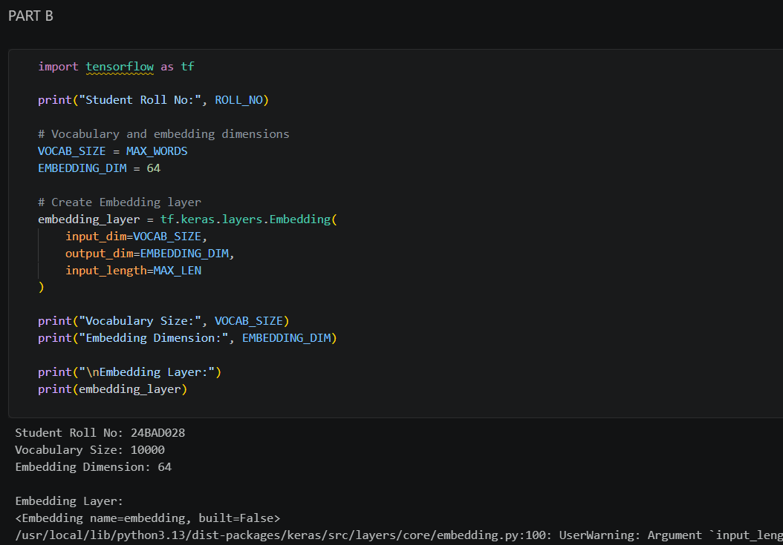
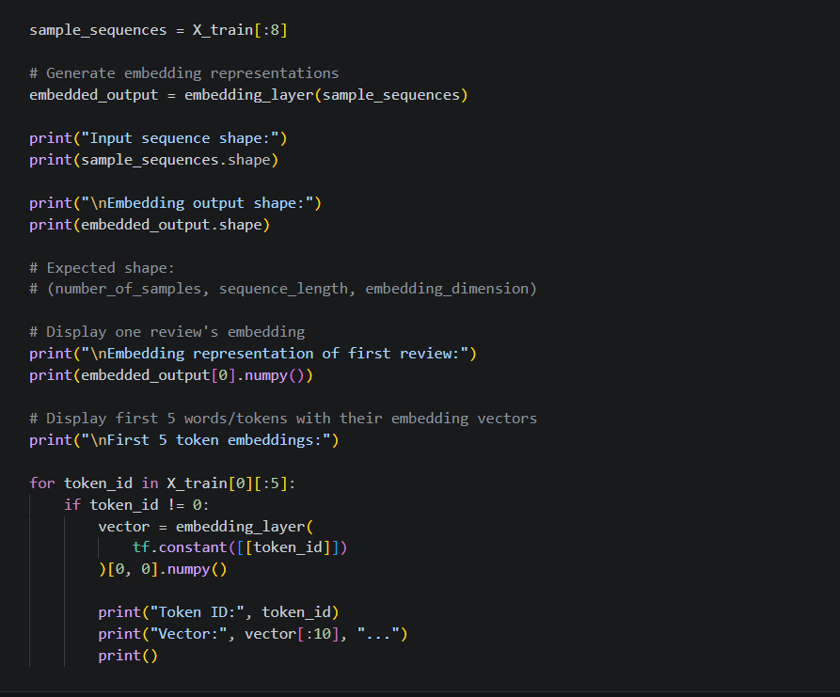
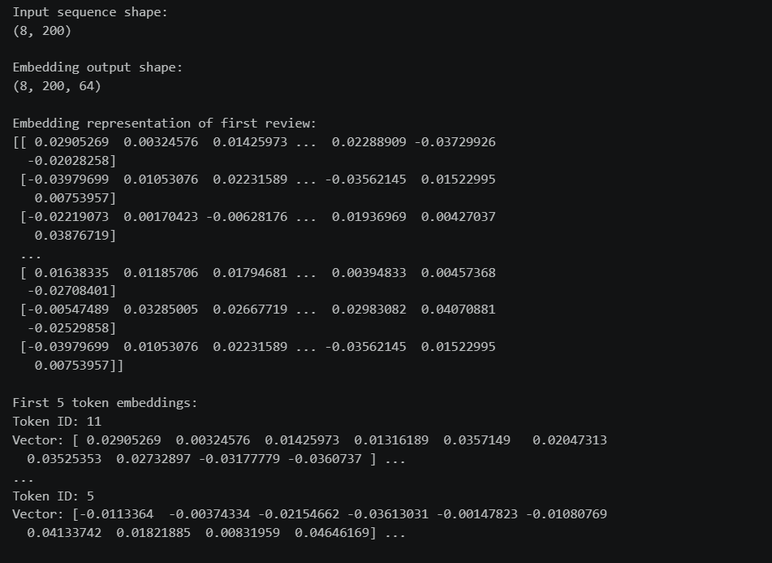
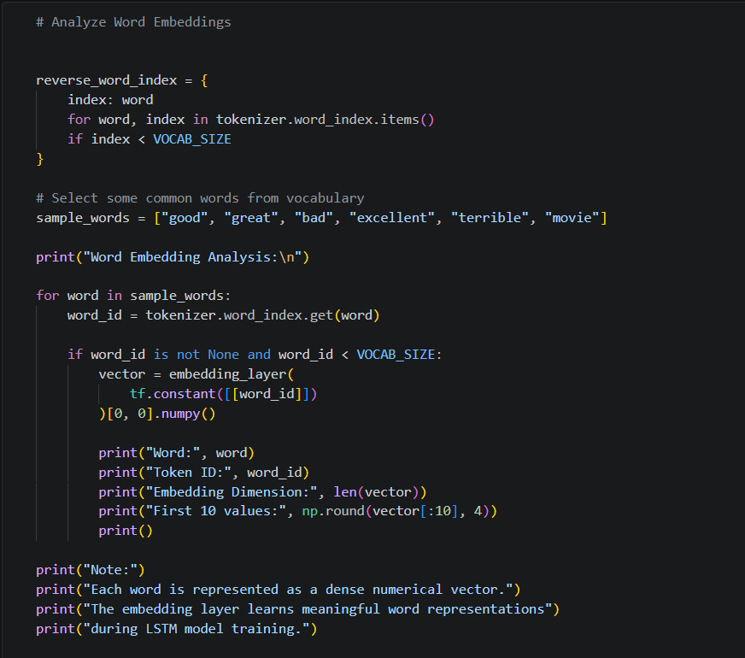
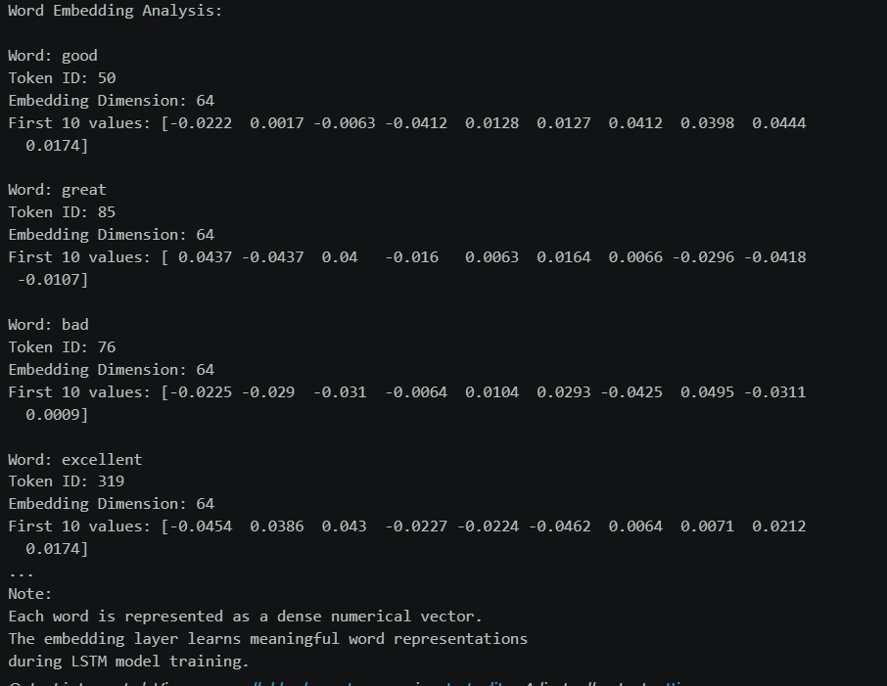

PART C: IMPLEMENTING THE LSTM MODEL
Perform the following tasks:
- Create an input layer for the padded text sequences.
- Add an Embedding layer to generate dense word representations.
- Add an LSTM layer to learn sequential dependencies in the reviews.
- Add a Dense output layer with an appropriate activation function for sentiment classification.
- Compile the model using:
  - Appropriate optimizer
  - Binary cross-entropy loss
  - Accuracy as the evaluation metric
- Display the model architecture and summary.

Screenshot of the code and output :

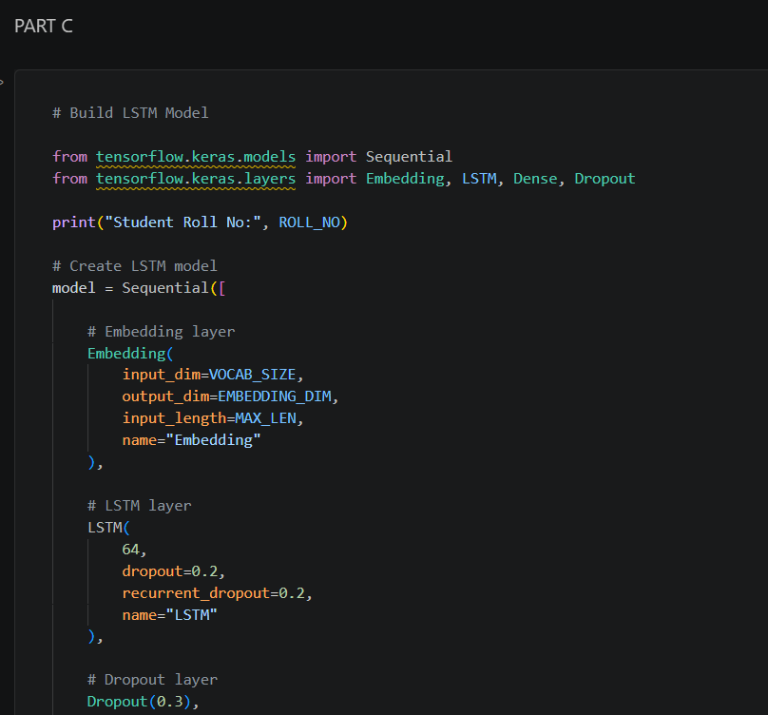
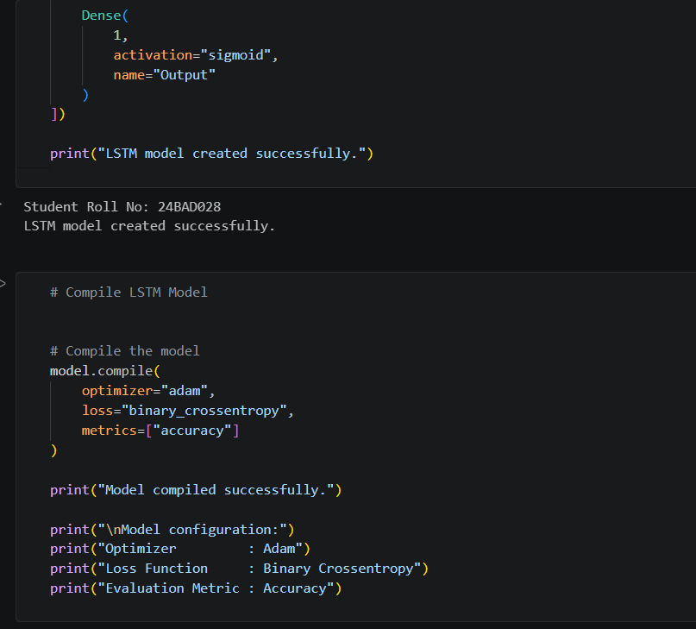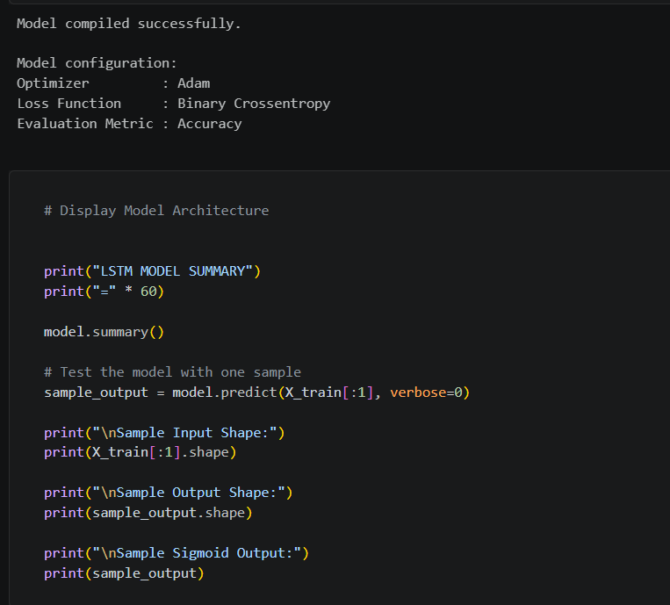
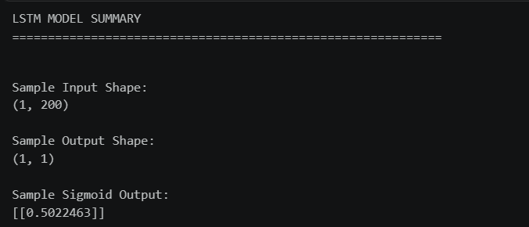

PART D: MODEL TRAINING AND SENTIMENT PREDICTION
Perform the following tasks:
- Train the LSTM model using the prepared training dataset.
- Validate the model using the validation dataset.
- Record:
  - Training accuracy
  - Validation accuracy
  - Training loss
  - Validation loss
- Visualize:
  - Accuracy vs. Epoch
  - Loss vs. Epoch
- Evaluate the trained model using the test dataset.
- Predict the sentiment of sample reviews.
- Compare the predicted sentiment with the actual sentiment.
- Calculate appropriate evaluation metrics such as:
  - Accuracy
  - Precision
  - Recall
  - F1-score

Screenshot of the code and output :

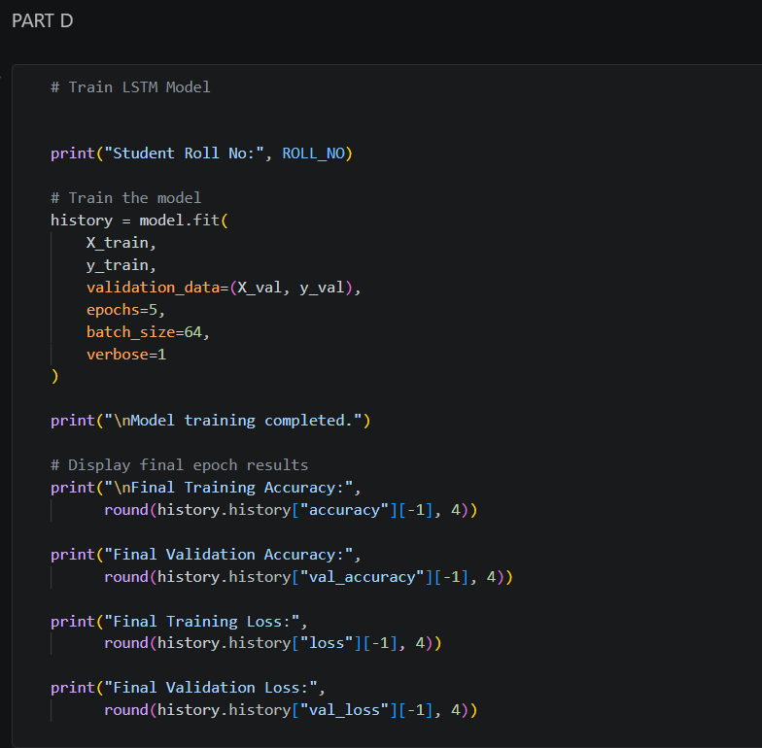
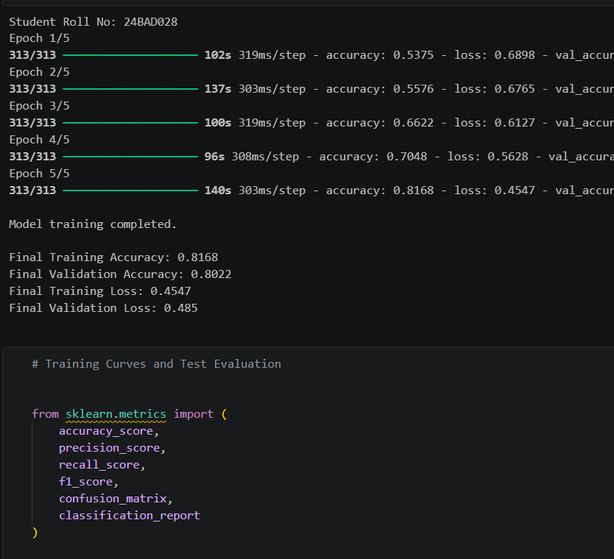
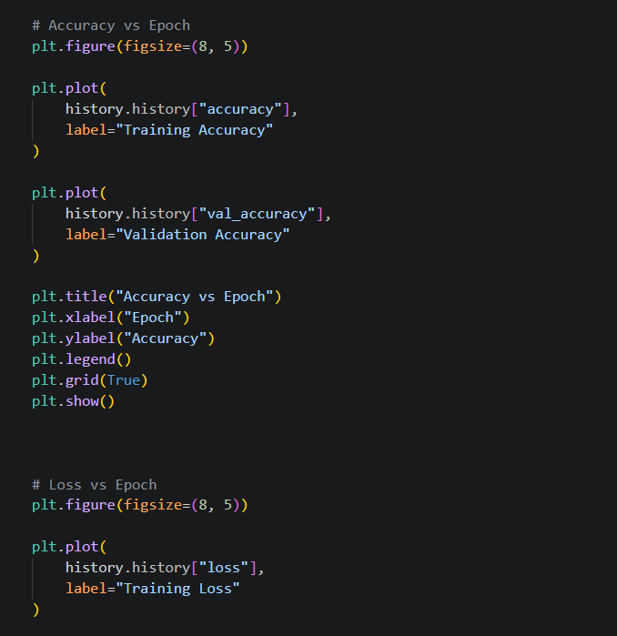
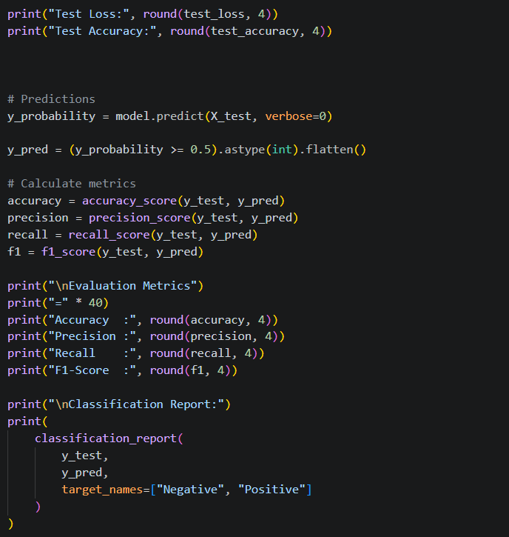
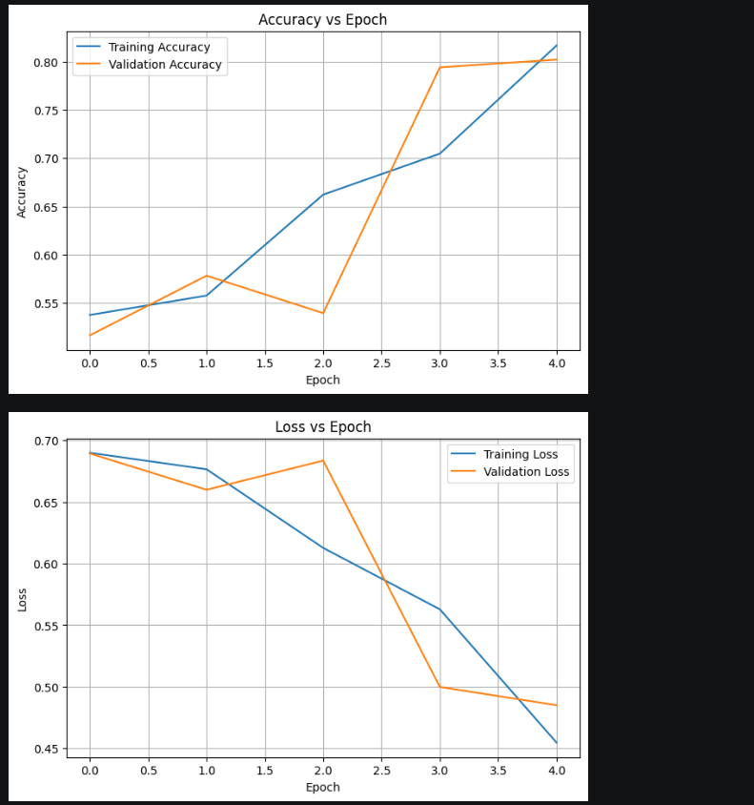
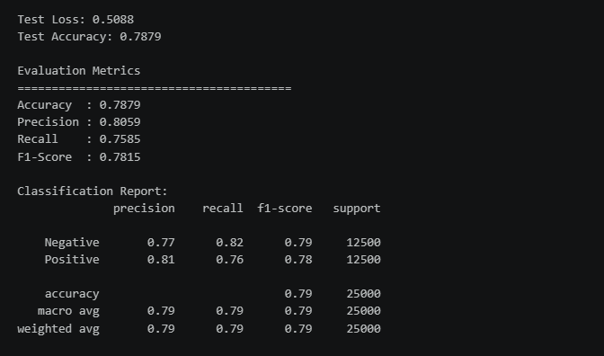
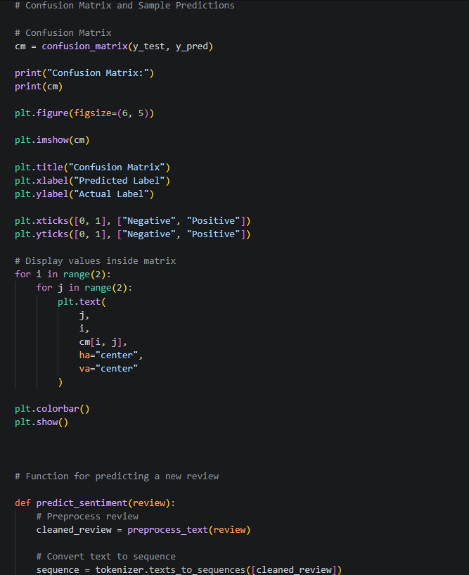
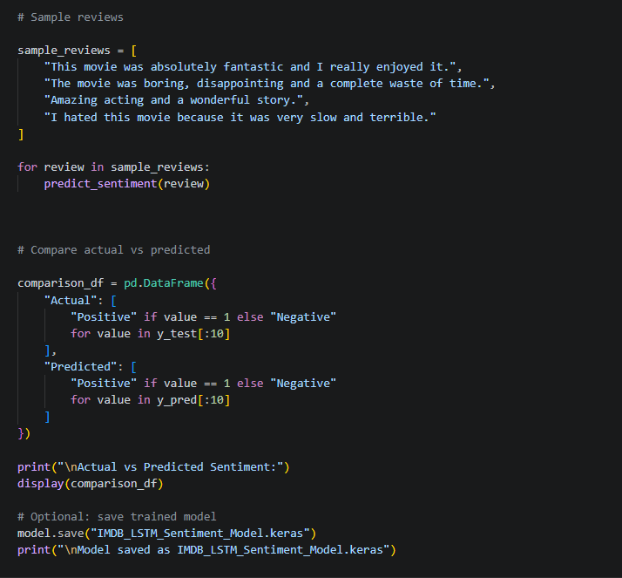
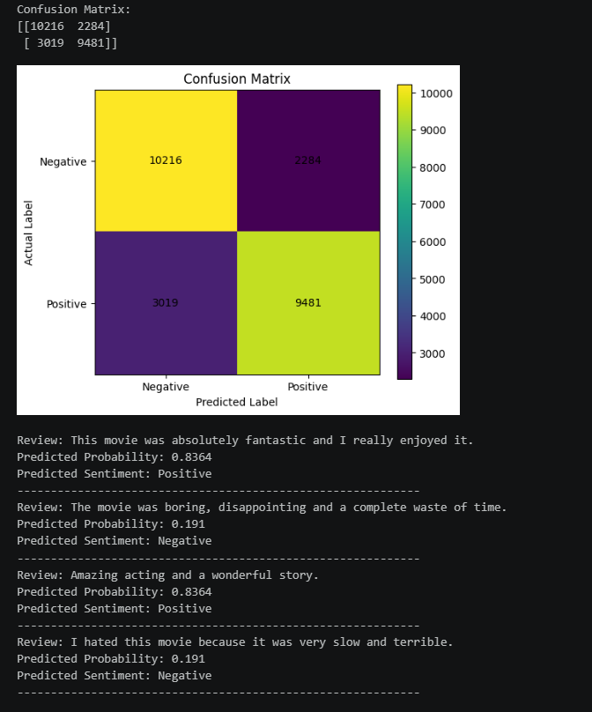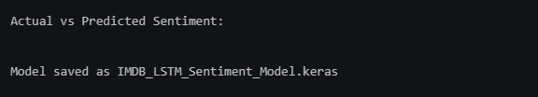

EXPECTED OUTCOME
Students will understand how LSTM networks learn sequential information from textual data and apply them to sentiment classification. Students will learn to perform text preprocessing, tokenization, sequence padding, and embedding generation using NLP libraries. They will build and train an LSTM model and evaluate its ability to classify reviews into positive and negative sentiments.

POST-LAB QUESTIONS

- What is the role of the memory cell in an LSTM?
The memory cell stores important information from previous time steps and helps the LSTM remember long-term dependencies.

- How does an LSTM overcome the vanishing gradient problem of a Simple RNN?
LSTM uses memory cells and gates to control the flow of information, allowing gradients to pass through longer sequences more effectively.

- What is the purpose of the Embedding layer in the sentiment analysis model?
The Embedding layer converts words represented as numerical tokens into dense vectors that capture useful relationships between words.

- How does padding affect the input to an LSTM network?
Padding makes all text sequences the same length, allowing them to be processed together by the LSTM.

- What happens when the LSTM model is trained for too many epochs?
The model may overfit, meaning it performs well on training data but poorly on unseen data.

- Why are precision, recall, and F1-score useful in addition to accuracy?
They provide more detailed information about classification performance, especially when the classes are imbalanced
.
- Give one limitation of using LSTM for sentiment analysis.
LSTM models can require significant training time and computational resources for large text datasets.

SUGGESTIONS FOR DATASETS
- IMDB Movie Reviews – https://ai.stanford.edu/~amaas/data/sentiment/
- SST-2 (Stanford Sentiment Treebank) – https://huggingface.co/datasets/stanfordnlp/sst2
- Twitter Sentiment Analysis – https://www.kaggle.com/c/twitter-sentiment-analysis
- Stanford Sentiment Treebank (SST) – https://huggingface.co/datasets/stanfordnlp/sst
- Amazon Product Reviews – https://huggingface.co/datasets/amazon_polarity
- Yelp Polarity Reviews – https://huggingface.co/datasets/fancyzhx/yelp_polarity

ASSESSMENT
Description | Max Marks | Marks Awarded
Pre Lab Exercise | 5
In Lab Exercise | 10
Post Lab Exercise | 5
Viva | 10
Total | 30
Faculty Signature

